Partial Derivatives

A partial derivative of a function of multiple variables is the derivative with respect to one of those variables, while keeping the other variables constant. It measures how the function changes as only the specified variable changes.
Given a function f(x,y), the partial derivatives with respect to x and y are defined as:
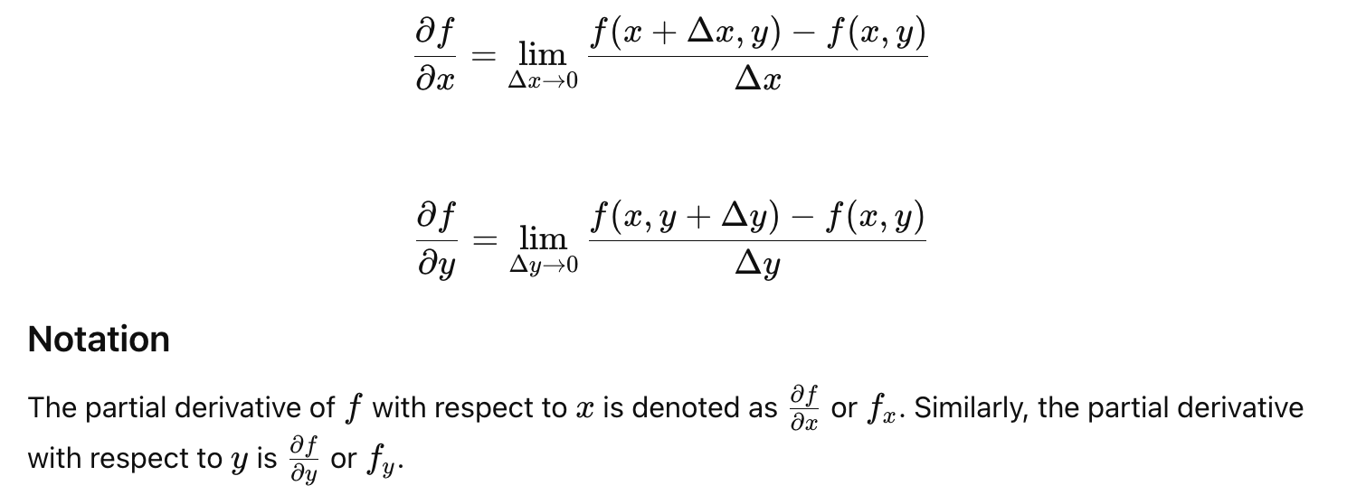

Relevancy to Machine Learning
Partial derivatives are essential in machine learning for optimizing models, backpropagation in neural networks, and feature sensitivity analysis. They enable efficient optimization algorithms like gradient descent, which are fundamental to training and fine-tuning machine learning models. Understanding partial derivatives is crucial for anyone involved in developing or improving machine learning algorithms.
Partial derivatives are crucial in machine learning for several reasons:
- Gradient Descent Optimization:
  - Gradient: In the context of functions of multiple variables, the gradient is a vector of partial derivatives. It points in the direction of the steepest ascent.
  - Gradient Descent: An optimization algorithm that uses the gradient to minimize the cost function by iteratively adjusting the parameters. Each parameter is updated by subtracting a fraction of the partial derivative of the cost function with respect to that parameter.
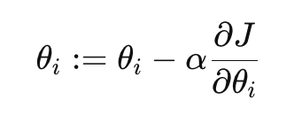
where θ_{i} are the parameters, J is the cost function, and α is the learning rate.
- Backpropagation in Neural Networks:
  - Error Propagation: In neural networks, the backpropagation algorithm uses partial derivatives to propagate the error backward through the network, calculating the gradient of the loss function with respect to each weight.
  - Weight Updates: These gradients are then used to update the weights in the network to minimize the loss function.
- Optimization in Multivariable Functions:
  - Many machine learning algorithms involve optimizing functions of multiple variables (e.g., logistic regression, support vector machines).
  - Partial derivatives help in understanding how the function changes with respect to each variable, enabling efficient optimization.
- Regularization:
  - Techniques like L1 and L2 regularization add penalty terms to the cost function to prevent overfitting. The gradients of these regularization terms with respect to the model parameters are partial derivatives.
- Feature Sensitivity Analysis:
  - Partial derivatives are used to analyze how sensitive the model's predictions are to changes in the input features. This helps in feature selection and engineering.

Examples in Machine Learning
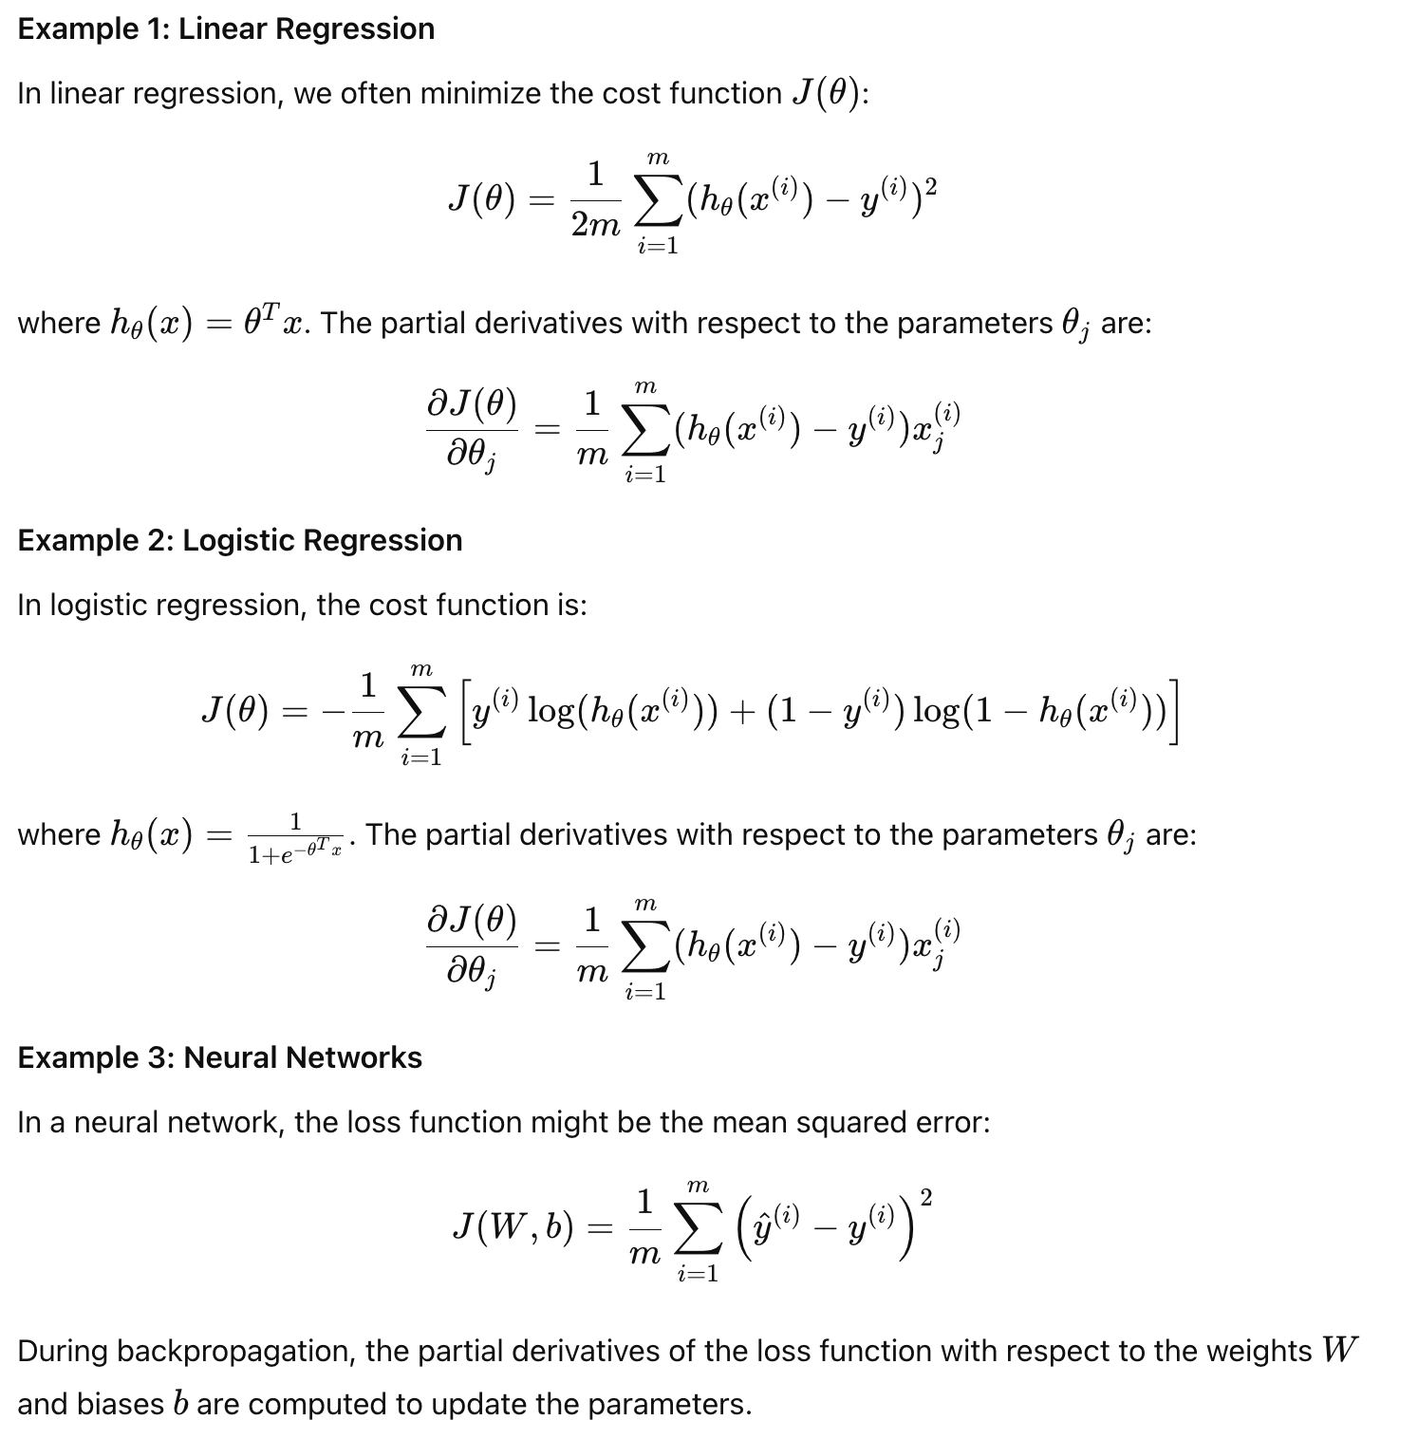

Partial Derivative Rules
Partial derivatives follow similar rules to ordinary derivatives, but they apply to functions of multiple variables. Here are the key rules for partial derivatives:
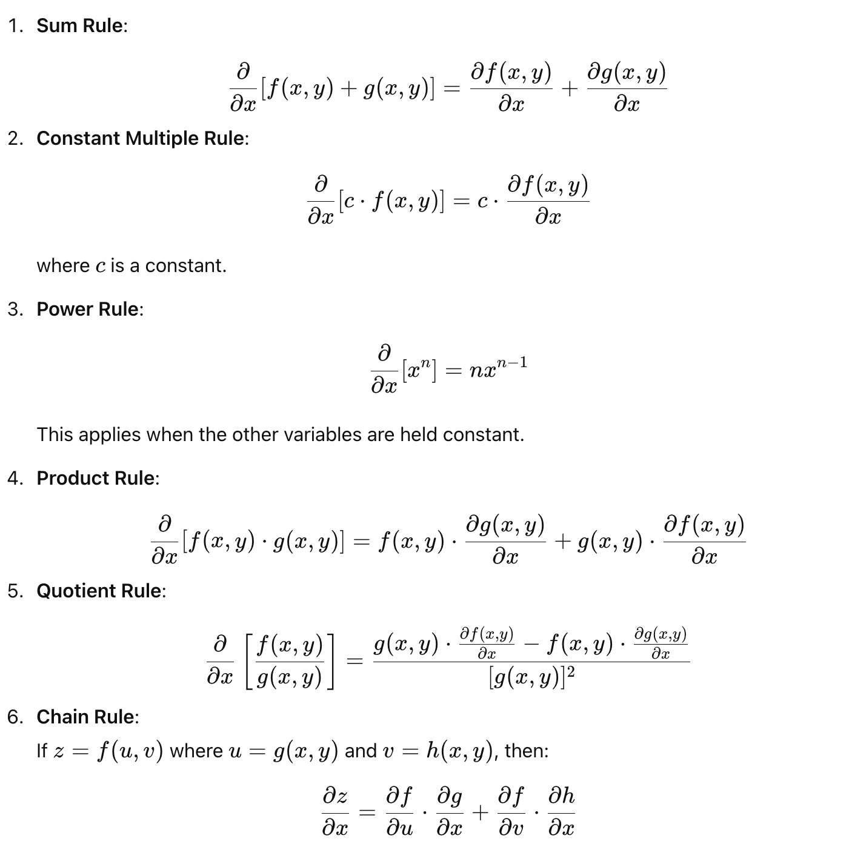
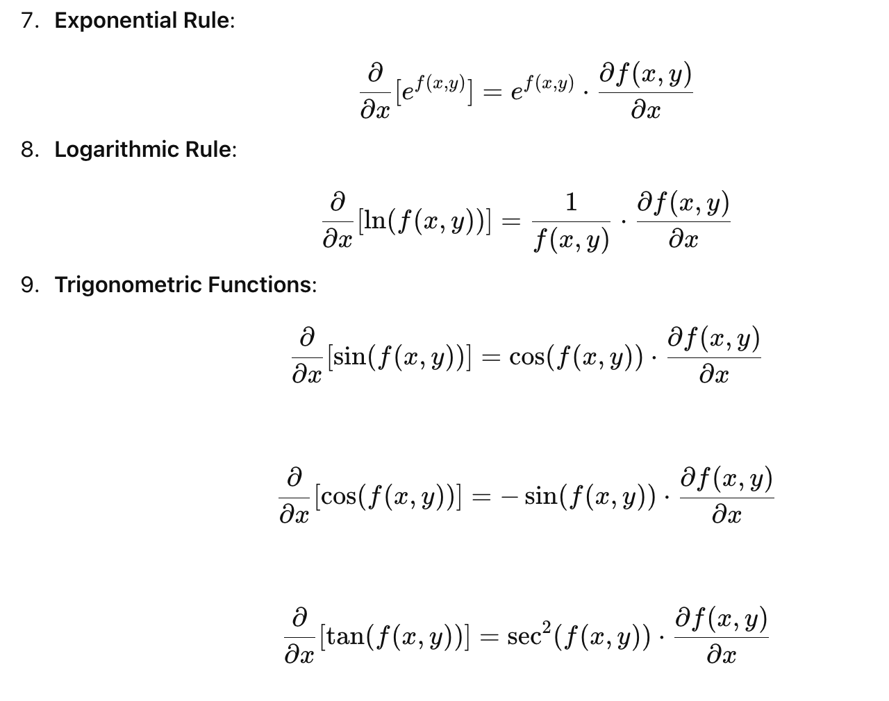

Worked Examples

Partial derivatives are essential in multivariable calculus and machine learning. They provide the foundation for optimization algorithms, such as gradient descent, and play a critical role in backpropagation for training neural networks. Understanding partial derivatives and their rules is crucial for developing and improving machine learning models.

